
ALLEGRINI TERRACE SPRING NEWSLETTER
Volume 1 / Spring 2023

New Mowing Company
TANNER’S LAWN CARE is the new lawn care provider for Allegrini Terrace. This lawn care service includes a 5-step fertilizer and weed control program is included as part of the services provided.
Mowing day: Wednesday, potentially April 12th, weather permitting
Weekly Mowing:
- Edging – when necessary
- Trimming grass around homes, trees, fences, and all landscaping weekly
- Blowing all grass off all concrete areas and structures
- Equipment: We will use small stand on and push mowers where limited space is available

Fertilizer Service - 5 Step Application.
Lawn Care Reminders!
Every Tuesday evenings we ask that you do the following before Tanner’s Lawn Care shows up for mowing on Wednesdays:
- Pick up any children’s toys, pet toys/leashes and any other items.
- Pick up any debris, rock etc. that could cause damage to property or lawn equipment.
- Lift downspouts prior to Wednesday mornings.
- Make sure garbage cans are not left on the grass.
- Pick up any dog waste prior to Wednesday morning, or the company may skip your lawn. They will not mow your lawn if there is excessive dog waste.

- First and Second treatments will be a mix of pre-emergent and fertilizer. 1st application applied between April 1st -April 14th.
- 2nd application applied 3-4 weeks later.
- 3rd application mid-June Grub Control.
- 4th application is a fall slow -release fertilizer and will be applied around Labor Day.
- 5th application is a winterizer which will be applied usually the week of Halloween or after last mowing.
- During each applied application we will also spray for previous and emerging infested weed areas. Residents will be notified before each application.





Why do flowers have so many friends?
Because they have so many buds!

Irrigation System Update
Report Water Issues
Everyone is encouraged to report problems with the irrigation system to the management company. Timely reporting of problems can save the HOA, in turn, homeowners money in lost water resources.
Common items such as broken sprinkler heads, irrigation lines and boxes and flooding in common areas should be reported. Do your part to keep HOA expenses and payments down by reporting landscape problems.
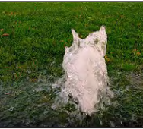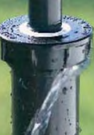

Hero’s Irrigation is the new company that will be maintain the irrigation system for Allegrini Terrace.
They will be out next week to pressurize the system. In the middle of April, weather permitting, they will start up the system and start checking for leaks.
With the rainy season starting up (keep your fingers crossed that Mother Nature cooperates this year). Hero’s does not plan on starting up the irrigation system until it is needed.

GOT A DOG? The board has heard some concerns from homeowners regarding unleashed animals and barking dogs. The City of Lincoln requires all dogs be leashed when they are outside and not in an enclosed yard. The common areas are not dog runs. Enjoy the common areas, but please keep the dogs on leash and pick up the poop. Did you know the average dog droppings contains over three billion fecal coliform bacteria? Yikes!
TRASH CAN POLICY Please place trash cans at the bottom of driveway either the night before or morning of pickup. When not on the street for trash pick-up, all trash receptacles are to be stored in the garage. During high winds, please safely secure trash bags and bins to prevent litter being blown everywhere. You are responsible to pick up your blown trash.
Backstory: The big reason for this policy is help with 1) litter, 2) pest and animal control, 3) refuse bins blown around during heavy winds. But more importantly, it reduces health & safety risks. Trash containers, even if they are empty, attract wild animals and are a contamination risk to children or adults who meet them.

Annual Meeting and Board Elections
Come meet your neighbors, learn what your dues pay for, learn more about how and why decisions are made and what’s happening in the future. Get involved and volunteer to be on the board! Your Community Needs You!
April 27th, 7pm, New Covenant Church, S 84th St.

Spring, Summer and BBQ
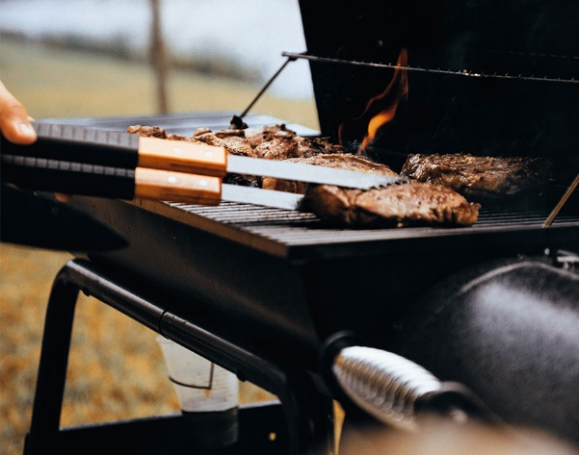
It’s officially grilling season, which means it’s time to fire up the barbecue and enjoy some delicious food. However, if you live in an HOA community, there are some guidelines that you need to follow to stay within the rules. Here are some helpful tips that’ll ensure your cookout goes smoothly.
- Be aware of your surroundings. Place the grill at least 5 feet away from your structure, low hanging branches and other items.
- Be safe and responsible, use proper grilling techniques and never leave the grill unattended.
- Please clean your grill after each. If using charcoal, please properly dispose of the ashes.


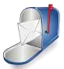
MAIL BOX
We have received a few of questions since the beginning of the year. Thought we would share the answers with everyone.
Question: What the heck are those pink dots and dashes on the street?
Answer: We have put out 3 bids for street repair costs. In order to prepare a 3-to-5-year reserve plan, the board needs to receive estimated costs and which areas need attention first. The concrete work may not start this year as our biggest issue is getting the irrigation system repaired and updated. More information will be discussed at the annual meeting.
Question: How do I setup my autopay on the secure portal? I want it to automatically pay on the first of each month?
Answer: Email mmccombs@mccrealty.com with your email address and mobile number. We will email you a link to register for the secure portal. Please use your routing/checking account numbers as there is no fee. Using a debit/credit merchant fees applied will be applied.
Question: Who can park in the guest parking areas? I have been towed a couple of times.
Answer: Guest parking is used for your guests that come over for a party or dinner, etc. If your guest plans to stay for a longer period, please contact the management company. They will determine, if they can park in the guests lots for or purchase a guest pass. Please call 402.435.0000 for more information.
Question: Can I get a parking tag for my roommate? How much does it cost?
Answer: Yes, please contact the management company at 402.435.0000 and ask for anyone on the HOA team. The cost of the parking pass is $250 for the year. The tag must be displayed from your rearview mirror. If you lose the parking tag, you will be charged $75 for a replacement tag.
Question: Are there any fines that I need to aware of?
Answer: Fine schedule for 1st infraction is $25, 2nd infraction $50, all subsequent infractions are $100.
Fines may be applied for trash cans, dog waste, Maintenance of landscaping, satellite dishes, use of commons, and parking.

Got questions??? Call the management company 402.435.0000 with any questions you have. You can also send an email to mmccombs@mccrealty.com

We are happy to help!

